MARCH BLOCK PARTY
Modern Irish Chain

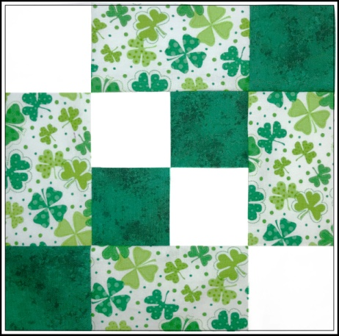
For this easy March block, you’ll need a St. Patrick’s Day or other green print, a green blender or solid, and a white blender or solid.

Cutting;
- Green print: Cut 4 pieces 2.5 x 4.5 inches
- Green: Cut 1 strip 2.5 wide x 10 inches long; sub cut into 4 2.5-inch squares
- White: Cut 1 strip 2.5 wide x 10 inches long; sub cut into 4 2-5-inch squares
- Press and lightly starch all the pieces

Sewing (.25-inch seams)
- Arrange the pieces as shown in the picture.
- Sew the center 4-patch together.
- Sew a print rectangle to each side of the center 4-patch.
- Sew the top row together with 1 white square, 1 print rectangle, and 1 green square
- Sew the bottom row together with 1 green square, 1 print rectangle, and 1 white square
- Before sewing the next seams, check the direction the matching seam allowances are pressed so the next seams will nest.
- Sew the 3 rows together to make the block and press well. Don’t trim to final size. Let the winner of the blocks do the final trimming.

Finished block will measure 8.5-inches

To participate in the March Block Party, make the block as described; mail or drop off to Karel Peer. Your name will be entered once for each block received (enclose a note if you don’t want your name in the drawing). Blocks must be received by Saturday, March 25th. The winner will be drawn during the March 27th meeting and will be in the April newsletter. Sharon Frieson & Karel Peer

